OBLIG1

Beslutninger.py

Dato.py

Dato2.py

Variabler.py

OBLIG 2

Fahrenheit_celcius.py

Quiz.py

Utskriftsfunksjon.py

OBLIG 3

Billettpris.py

Lister.py

Matplan.py

Egenoppgave.py

Ordbok.py

OBLIG 4

Egenoppgave.py

Funksjoner.py

Funksjonergammel.py

Ordtelling.py

Reiseplan.py

OBLIG 5

Egenoppgave.py

Regnefunksjoner.py

Repetisjon1.py

Skop.py

Temperatur.py

OBLIG 6

Hund.py

Motorsykkel.py

Person.py

Salgstall.py

Telefonsalg.py

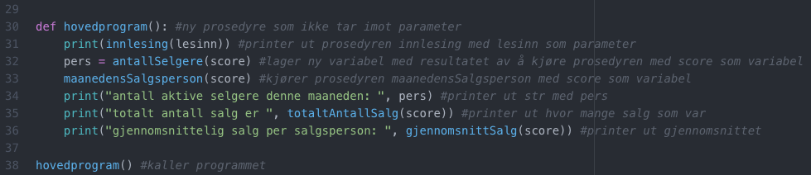

Teori.txt

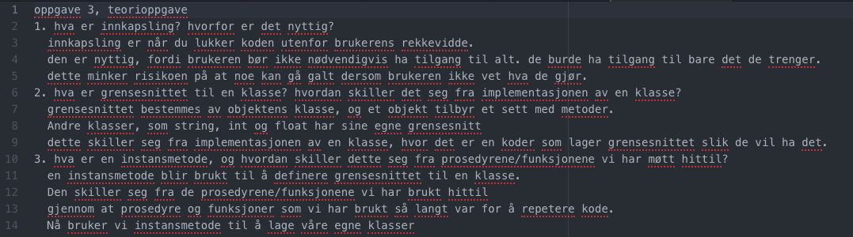

testMotorsykkel.py

testperson.py

OBLIG 7

Musikk.txt

Sang.py

Sangtester.py

Spilleliste.py

Text.txt

OBLIG8

Celle.py

Spillebrett.py

Main.py

